EXPERIMENT 2 :

Aim :

Verifying the performance of a multi class confusion matrix by using choosen database with python code.

Program :

from sklearn.datasets import load_breast_cancer

from sklearn.model_selection import train_test_split

from sklearn.tree import DecisionTreeClassifier

from sklearn.metrics import confusion_matrix, accuracy_score,precision_score,recall_score, f1_score

import matplotlib.pyplot as plt

import seaborn as sns

X,y=load_breast_cancer(return_X_y=True)

x_train,x_test,y_train,y_test=train_test_split(X,y,test_size=0.25, random_state=23)

tree=DecisionTreeClassifier()

tree.fit(x_train,y_train)

y_pred=tree.predict(x_test)

cm=confusion_matrix(y_test,y_pred)

accuracy=accuracy_score(y_test,y_pred)

print('Accuracy : ',accuracy)

precision=precision_score(y_test,y_pred)

print("Precision : ",precision)

recall=recall_score(y_test,y_pred)

print("Recall : ",recall)

F1_score=f1_score(y_test,y_pred)

print("F1-score",F1_score)

sns.heatmap(cm,annot=True,cmap='pink',xticklabels=['malignant','benign'],yticklabels=['malignant','benign'])

plt.ylabel('Prediction')

plt.xlabel("Actual")

plt.title('Confusion Matrix')

plt.show()

Output :

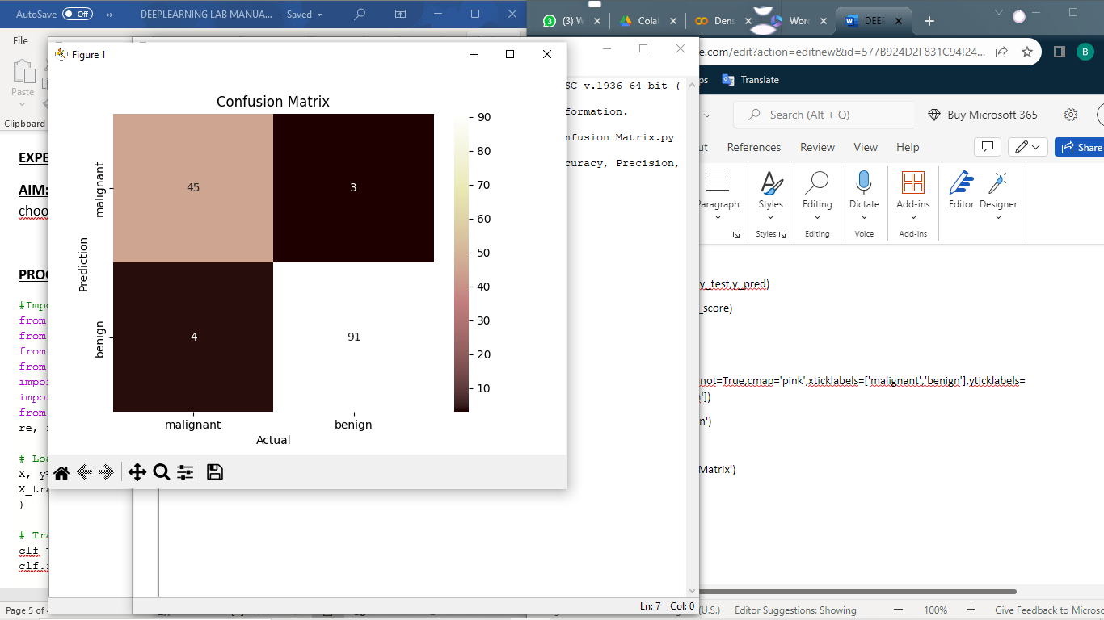

Accuracy : 0.951048951048951

Precision : 0.9680851063829787

Recall : 0.9578947368421052

F1-score 0.962962962962963